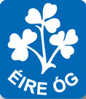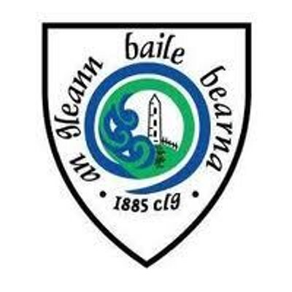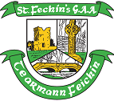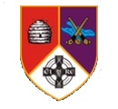

Feile na Gael 2017
Glynn Barntown Camogie & GAA Club welcomes Eire Og Camogie Club,Na Piarsaigh, and St. Fechins, GAA Club.
Schedule of Events
Friday 16th June 2017

7pm -9pm Meet and Greet for All teams and Parents
Handover of Players to their host families & food for all at
Glynn Barntown GAA Club. Players will probably leave with host families about 9-9.30pm.
Bar in Clubhouse open on Friday night. All are welcome.

SATURDAY 17th June 2017.
8.45am Assemble for Feile Parade at Glynn Barntown GAA
Club
9:00am Parade begins. 6 teams.
10:00am Glynn Barntown V St. Fechins
10:45am Glynn Barntown v Eire Og Annacarty
11:30am Glynn Barntown V Na Piarsaigh
12:00pm Lunch served to all players and Mentors in the Clubhouse. Parents and Supporters can avail of Tea and Sandwiches in the Marquee.
Depending on results from the games will determine what time Quarter finals are at. But we will all be heading to either
Bunclody for the Camogie Teams.
Shield Quarter Finals are 3:45pm
Cup Quarter Finals are 5:30pm
Tinryland, Carlow for the Division 11 Boys Teams
Shield Quarter Finals are 3:45pm
Cup Quarter Finals are 5:15pm
Ferns Centre of Excellence for Division 2 Boys Teams
Shield Quarter Finals are 4.30pm
Cup Quarter Finals are 5:15pm
9:00 pm – 11:00 ish. Disco with DJ for younger people
in marquee
9:00 pm – 1:00 am Music in Clubhouse for the
slightly older people

Sunday 18th June 2017
This will depend on our results over the weekend.
Ferns Centre of Excellence
Camogie Division 1 Shield Semi Finals 11.30am
Camogie Division 1 Cup Semi Finals 11.30am
Camogie Division 1 Shield Final 3.45pm
Camogie Division 1 Cup Finals 3.45pm
Hurling Division 2 Shield Semi Finals 12.15pm
Hurling Division 2 Cup Semi Finals 12.15pm
Hurling Division 2 Shield Final 3.00pm
Hurling Division 2 Cup Finals 3.00pm
Tinryland Carlow
Hurling Division 11 Shield Semi Finals 10.00am
Hurling Division 11 Cup Semi Finals 10.45am
Hurling Division 11 Shield Final 1.30pm
Hurling Division 11 Cup Finals 1.30pm

